ShopNest Store Capstone Project

Priyanka Shrikhande
16th November 2025

ShopNest stands as the leading department store in the e-commerce marketplaces in Portugal. Serving as a seamless link, it connects small businesses from various regions in Portugal to channels, streamlining the process with a single point of contact. Through the Shop Nest Store, these merchants can showcase and sell their products, with the added convenience of direct shipment to customers facilitated by Shop Nest logistics partners. The provided data represents authentic commercial information that has undergone the process of anonymization.

- Top Categories by Total Sales

- Data Overview:

The dataset includes sales data for various product categories, detailing the product category and the sales amount for each transaction.

- Visual Representation:

A horizontal bar chart is used to depict the top 10 product categories by total sales, where each bar's length correlates with the total sales amount, illustrating their dominance.
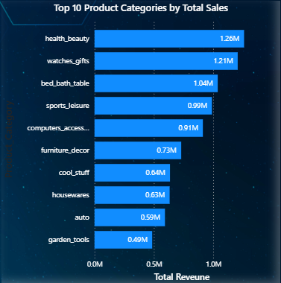

- Explanation:

- Analysis Approach:

Sales data is aggregated by product category, and the total sales amount for each category is calculated. The categories are then ranked by sales volume, with the top 10 highest-selling categories selected for detailed analysis and visualization.

- Findings:

The top 10 categories by total sales are:
- Health & Beauty
- Watches & Gifts
- Bed Bath & Table
- Sports & Leisure
- Computers & Accessories
- Furniture Decor
- Cool Stuff
- Housewares
- Auto
- Garden Tools

These categories significantly outperform others, reflecting strong consumer demand. Categories like Health & Beauty, Watches & Gifts and Bed Bath & Table are particularly noteworthy for their consistent high sales.

- Insights:

1.Categories such as Cool Stuff, Computers & Accessories, and Watches & Gifts cover a wide range of products, appealing to varied consumer interests.

2. Household and recreational products (Housewares, Bed Bath & Table, and Sports & Leisure) are key drivers of overall sales.

- Conclusion and Recommendations:
Understanding top-performing categories offers insights into consumer preferences and market trends. Businesses should focus on optimizing strategies for these high-performing categories, explore cross-selling opportunities, and continuously monitor sales trends for adaptive strategies.

2. Gross Profit Analysis:

- Data Overview:

- The dataset includes order information such as Gross Profit (in Millions, M) and Product Category (labeled as product_category_name_english).
- Data Range (Gross Profit): The values range from approximately 0.35M to just over 1.0M.

- Visual Representation:

The data is represented using a vertical Bar Chart.

- X-axis: Represents the categorical variable, which is the Product Category Name (product_category_name_english).
- Y-axis: Represents the quantitative variable, which is the Gross Profit (ranging from 0.0M to 1.0M and slightly above).

The length or height of each bar is proportional to the Gross Profit generated by that specific product category. The descending order of the bars helps visualize the ranking of categories by profit.
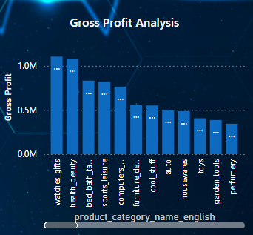

- Explanation:

Analysis Approach:
The bar chart provides a clear visual comparison of the gross profit contribution of different product categories.

- High-Profit Leaders: The categories watches_gifts and health_beauty stand out as the highest grossing, with profits nearing or just exceeding 1.0M. This suggests they are the primary drivers of overall gross profit.
- Mid-Range Performers: A cluster of categories, including bed_bath_table, sports_leisure, and computers_accessories, show a strong but slightly lower profit, hovering around 0.8M to 0.9M.
- Significant Drop-off: There is a noticeable drop in profit after the top five categories. Categories like furniture_decor and cool_stuff generate profit around 0.5M, indicating they contribute about half the gross profit of the leading categories.
- Low-Profit Categories: Categories like toys, garden_tools, and perfumery are at the lower end, generating significantly less gross profit (between 0.35M and 0.45M). These categories may warrant further investigation to determine if low gross profit is due to low sales volume, low price points, or high cost of goods sold (COGS).

- Recommendations:

- Invest Heavily: Focus marketing and inventory resources on the Top 2 Leaders (watches_gifts, health_beauty) to secure their $\approx$ 1.0M profit.
- Target Growth: Run promotions and cross-sell strategies for the Mid-Range (bed_bath_table, sports_leisure) to push their profit over 1.0M.
- Review/Optimize: Investigate the margins and volume of Lowest Categories (perfumery, garden_tools). Consider cost reduction, strategic promotions, or potential de-prioritization.
.

3. Monthly Comparison of Delayed and On-Time Orders:

- Visualization:

Below line graph is depicting the delayed orders’ comparison with the on-time delivered orders month wise. On the x-axis are the months differentiated by the markers on the line and count of orders delayed or on – time are represented on the y-axis.

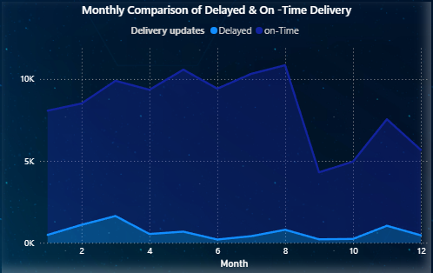

- Explanation:

- Findings:
- June: Lowest delayed orders 204, indicating high operational efficiency.
- Followed by September (217) and October (240) respectively.
- August: Highest on-time orders (10044) despite high order volume, suggesting effective logistics management.
- Followed by July (9909) and May (9889) respectively.

Recommendations:
- Replicate best practices from June to maintain or improve delivery performance.
- Analyze August’s success factors to replicate effective strategies in future operations.
- Continuously monitor monthly performance to identify and act on improvement opportunities.

4. Payment Method Analysis:

- Data Overview:

The dataset includes transaction data specifying payment methods i.e. credit card, debit card, boleto, voucher and undefined.

- Visualization:

A tree chart showing the distribution of payment methods, highlighting the dominance of credit card payments.

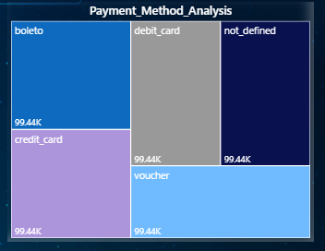

- Explanation:

- Findings and Insights:
- Credit Card: Most frequently used, indicating a strong customer preference.
- Boleto : Can be considered as the second most used mode of payment after credit cards.
- Voucher: Followed by Credit card and boleto.
- Debit Card: Used less frequently but still significant.
- Other Methods: Include cash, mobile payments, contributing to remaining transactions.

- Recommendations:
- Businesses should prioritize credit card processing while offering diverse payment options to cater to different preferences.
- Regularly monitor payment trends and feedback to optimize payment systems.

5. Product Rating Analysis:

- Visual Representation:

- Here the analysis can be showed by two horizontal bar charts representing least and most rated product categories.
- Product categories can be seen on the Y-axis whereas the average ratings can be seen on the x-axis. Each bar has the data labels inside the end of themselves that shows the overall average review scores.

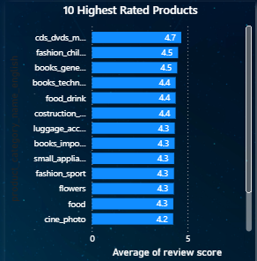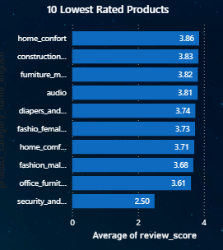

- Explanation:

Insights:
- High Ratings: Reflect superior quality and customer satisfaction.
- Low Ratings: Indicate issues needing resolution, such as quality or functionality improvements.

Here we can see the products that needs the resolution most are those which falls under the ‘lowest rated products’ whereas those products which reflect the superior quality and customer satisfaction are those which can be seen in the ‘highest rated products.

Recommendations:
Promote top-rated products and address deficiencies in low-rated products through targeted improvement initiatives.

6. State-wise Sales Analysis:

- Visual Representation:

The data is shown in stacked area chart, where on the x-axis we can witness the states and on the other hand on y-axis we can witness the total revenues.

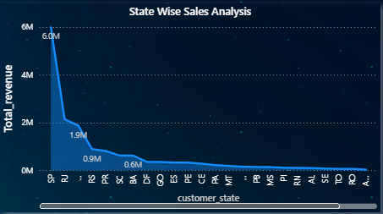

- Explanation:

- Findings:

- SP State shows consistently high sales, crucial for overall performance.
- States Like AM, AC, AP, RR are some of the states that are really doing worst and need some kind of attention as well as more attention or probably the functions shall be evoked from these states as to save the higher cost that are incurred to provide the products in these states.
- Regional Disparities: Significant variations in sales across states can be seen, as states like SP being exceptionally good, RJ, MG, RS, PR, BA are doing well in terms of revenues whereas states like, AM, AC, AP, RR are performing exactly the opposite hence creating the disparities.

- Recommendations:
  - Invest further in high-performing regions.
  - Investigate and enhance strategies in low-performing regions to boost sales.

7. Seasonal Sales Patterns:

- Visualization:

The data is shown in donut chart, where we can witness the total revenues along with year and quarter details.
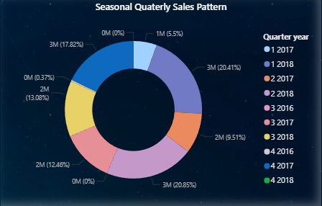

- Explanation:

- Findings:
- Quarter 2: Consistently highest sales, likely due to holidays and promotional events.
- Quarterly Variations: Other quarters exhibit moderate fluctuations.

- Recommendations:
Capitalize on Quarter 2 peak demand through strategic planning and resource allocation. Continuously monitor and adapt to seasonal sales trends.

8. Revenue Analysis:

- Visualization:

The data is visualized with clustered column chart where Quarter are shown on X axis and total revenue on Y axis along with distribution based on per year.
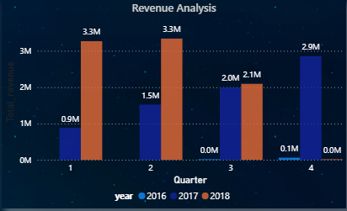

- Explanation:

- Findings:
- Total Revenue Trend: Shows overall performance and growth trajectory.
- Seasonal Variations: Reflect influences such as holidays and promotions.

- Insights and Recommendations:
Understanding revenue trends helps identify growth opportunities and informs strategic decisions in product offerings and marketing. Regularly monitor revenue and adjust strategies to sustain growth. Future analyses should consider additional factors influencing revenue, like pricing strategies and market dynamics.

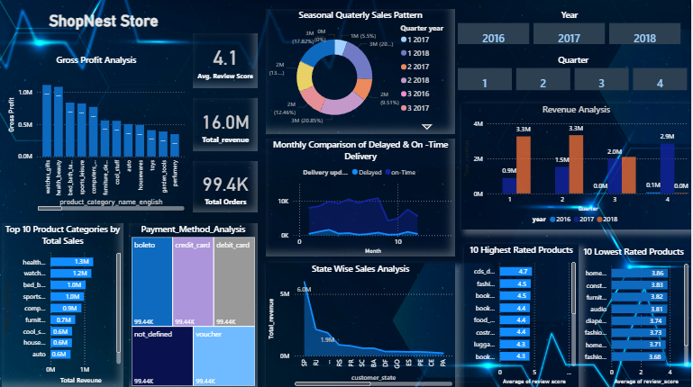
CONCLUSION

The comprehensive analyses conducted for ShopNest Store reveal critical insights into various aspects of its operations, from top-selling product categories and delayed order patterns to payment method preferences and regional sales performance. By examining these facets, ShopNest can strategically enhance its business operations and improve overall customer satisfaction.

- Key Findings and Recommendations:

- Top Categories by Total Price:
- Findings: Categories like Auto, Garden Tools, and Health & Beauty exhibit the highest sales.
- Recommendations: Focus on optimizing inventory, marketing efforts, and product assortment for these top-performing categories. Consider cross-selling and upselling strategies within these high-demand areas.

- Delayed Orders Analysis:
- Findings: Identified categories with high and low gross profits.
- Recommendations: Investigate the margins and volume of Lowest Categories (perfumery, garden_tools). Consider cost reduction, strategic promotions, or potential de-prioritization.

- Monthly Comparison of Delayed and On-Time Orders:
- Findings: July shows the lowest number of delayed orders, while August has the highest number of on-time orders.
- Recommendations: Leverage best practices from July to maintain delivery efficiency. Analyze August's performance to replicate successful strategies.
- Payment Method Analysis:
- Findings: Credit cards are the most frequently used payment method.
- Recommendations: Ensure robust credit card processing systems while offering a variety of payment options to cater to diverse customer preferences.

- Product Rating Analysis:
- Findings: Identified the top 10 highest-rated and bottom 10 lowest-rated products.
- Recommendations: Promote top-rated products and implement improvement initiatives for low-rated products to enhance overall customer satisfaction.

- State-wise Sales Analysis:
- Findings: SP state generates the highest sales orders.
- Recommendations: Allocate more resources to high-performing regions and develop tailored strategies to boost sales in underperforming states.

- Seasonal Sales Patterns:
- Findings: Quarter 2 consistently shows the highest sales volume.
- Recommendations: Plan marketing campaigns and inventory management around peak sales periods to maximize revenue.

- Revenue Analysis:
- Findings: Analysis shows trends in revenue generation over time, indicating overall growth and seasonal fluctuations.
- Recommendations: Regularly monitor revenue trends, identify growth opportunities, and adjust strategies to enhance long-term performance.

- Strategic Implications:

- Resource Allocation: Prioritize resources towards high-performing categories and regions while addressing areas needing improvement.
- Process Optimization: Implement continuous improvements in delivery processes, inventory management, and customer service based on data insights.
- Market Adaptation: Stay agile in response to market trends, consumer behavior, and seasonal variations to maintain a competitive edge.

- Future Considerations:

- In-depth Analysis: Further explore underlying factors influencing sales performance, such as demographic trends, pricing strategies, and competitive dynamics.
- Technological Integration: Invest in technology solutions for better tracking, data analysis, and customer relationship management to stay ahead of market changes.
- Customer Feedback: Continuously gather and analyze customer feedback to inform product development and service enhancement initiatives.

By leveraging these insights, Shop Nest Store can refine its strategic planning, optimize operations, and drive sustainable growth, ensuring continued success in the competitive e-commerce landscape.

